Kindly scan the QR code to open the app and find the link for the same as well.

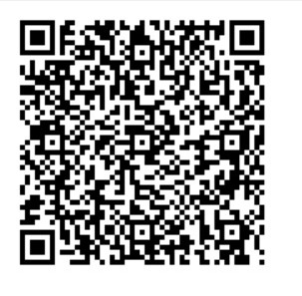

<https://studio.code.org/projects/applab/iY9F0yIKRVwUokPu4sFHgPD5vnYuiYTaTfZSSSdDSU8>

Note: click on view code to view the source code